For viewing the Power BI File:

1. Open the Microsoft Power BI Desktop Document.

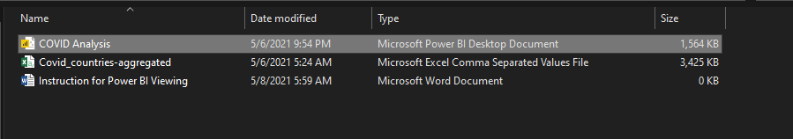

1. Go to data source settings and select Change Source.  
   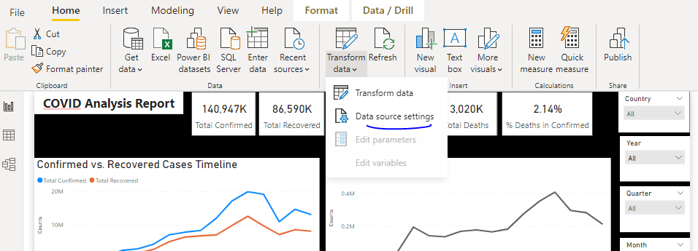

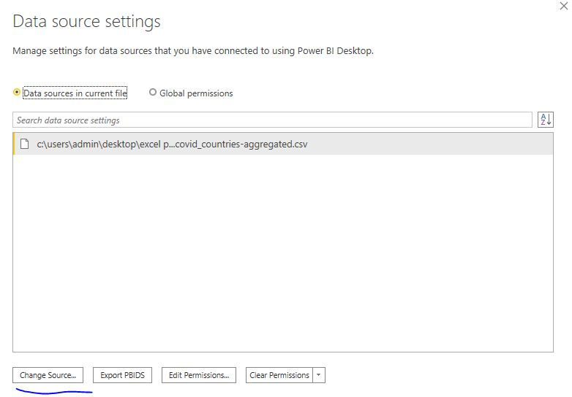

1. Change the directory to where the accompanied CSV files is located and select it.

